SQL MODEL

Ques
1. Book( sl_no, name, Language)
2. Chapters (sl_no (pk), book_sl(fk), name, start_page, end_page)
2.Autor ( sl_no, name, gender, Dob, Author_id)
3. Book_edition( sl_no, Book_sl (fk) , edition )
4. Book_Authors(sl_no, Book_sl (fk), Author_sl(fk))

1. Create table Book(
SL_NO int primary key,
NAME varchar(50) not null
Language varchar(20),
Price int
)
insert into Book values(1,'Kanuru Heggadati');
insert into Book values(2,'Half Girlfriend');
insert into Book values(3,'Revolution 2020');
insert into Book values(4,'Marry me Stranger');
insert into Book values(5,'Malegalalli Madhumagalu');

2.Create table Chapters (SL_NO int Primary Key,
BOOK_SL int,
NAME varchar(50),
START_PAGE int ,
END_PAGE int ,
foreign key (BOOK_SL) references BOOK(SL_NO) on delete cascade

insert into Chapters values(1,1,'Kanuru ch-1',4,10);
insert into Chapters values(2,1,'Kanuru ch-2',11,25);
insert into Chapters values(3,1,'Kanuru ch-3',11,25);
insert into Chapters values(4,2,'HG ch-1',07,17);
insert into Chapters values(5,2,'HG ch-2',18,45);
insert into Chapters values(6,3,null,null,null);
insert into Chapters values(7,5,'Stranger',03,25);
insert into Chapters values(8,5,'forget me not',26,70);
insert into Chapters values(9,5,'today or tommarow',71,105);

3. create table Autor (
SL_NO int primary key,
NAME varchar(50) not null,
GENEDER varchar(10)not null,
DOB date ,
AUTHOR_ID varchar(20) not null
)
insert into Author values(1,'Kuvempu','Male','12/08/1938','KAVI0011');
insert into Author values(2,'Chetan Bhagath','Male','05/05/1970','KAVI0022');
insert into Author values
(3,'Novneel Chakraburthy','Male','21/07/1995','KAVI0033');

4. create table Book_edition (
SL_NO int primary key,
BOOK_SL int ,
EDITION FLOAT,
foreign key (BOOK_SL) references BOOK(SL_NO));

insert into Book_edition values(1,1,1.0);
insert into Book_edition values(2,1,2.0);
insert into Book_edition values(3,1,3.0);
insert into Book_edition values(4,2,1.0);
insert into Book_edition values(5,4,10.0);
insert into Book_edition values(6,4,11.0);

5. create table Book_Author(SL_NO int primary key,
BOOK_SL int,
AUTHOR_SL int,
foreign key (BOOK_SL) references BOOK(SL_NO),
foreign key (AUTHOR_SL) references AUTHOR(SL_NO))

insert into book_author values(1,1,1);
insert into book_author values(2,2,2);
insert into book_author values(3,3,2);
insert into book_author values(4,4,3);
insert into book_author values(5,5,1);

Queries

1. --Select Book name and its author name

select b.name as Book_name, a.name as Author_name from Author a, Book b
join Book_Author ba on a.sl_no=ba.author_sl and b.sl_no=ba.book_sl
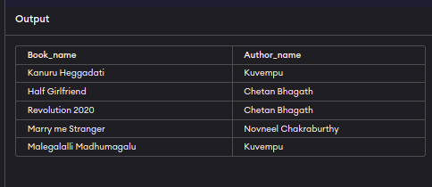
2. --Select Books which is written by Chetan Bhagath or Novneel Chakraburthy

select b.name as Book_name, a.name as Author_name from Author a, Book b
join Book_Author ba on a.sl_no=ba.author_sl and b.sl_no=ba.book_sl where
(a.name='Chetan Bhagath' or a.name='Novneel Chakraburthy')
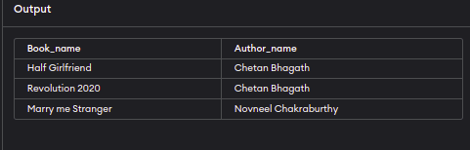
3. --select kannada language books

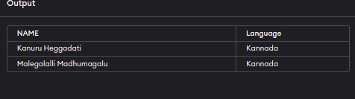
select name, language from Book where Language='Kannada'

4. --select Authors who born after 1950
select a.name from Author a where dob>'1950/12/31
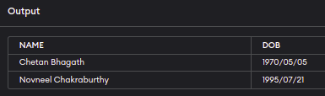
5. --get average price of all books
select avg(price) as Avg_Price from book

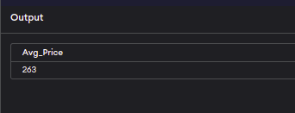
6. --get all chapters, starting page and ending page of book

Select b.name, c.name as chapter_name, c.start_page, c.end_page from Book b
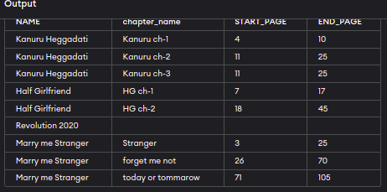
join Chapters c on b.sl_no=c.book_sl

7. --get count of chapters for each book

select B.NAME AS Book_name, count(c.name) as Chapter_count from Book b
inner join Chapters c on b.sl_no=c.book_sl group by b.name

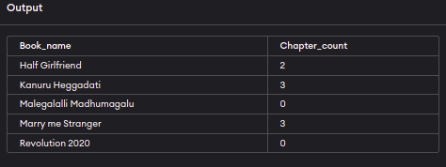
8. --get count of books in each language

select language , count(language) as No_of_books from Book
group by language

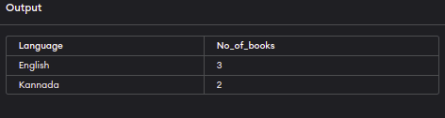
9. --get books name and cost of book in Accending order of price

select name, price from Book order by price
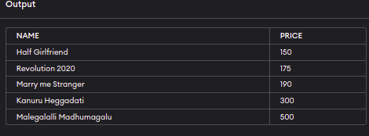
11. --get books name starts with M

select name from Book where name like 'M%'

